Brooklyn torah gazette
For yom tov pesach 5781
Volume 5, Issue 31 (Whole # 231) 15-22 Nissan 5781/ March 28-April 4, 2021
Printed L’illuy nishmas Nechama bas R’ Noach, a”h

Gebrochts – an Overview
By Rabbi Yair Hoffman

There is a minhag in many families of Klal Yisroel to avoid eating gebrochts.
And yet, the Shulchan Aruch (OC 461:4) writes that one fulfills the Mitzvah of Matzoh with matzoh shruyah – gebrochts, soaked Matzah – as long as the Matzoh remains intact and whole. This is based upon the Gemorah itself (Psachim 41a) which states the very same law.

What is the Source
What then is the source for the custom of avoiding Gebrochts – dipped or wetted Matzoh? Almost without exception, the custom to refrain from Gebrochts has spread throughout the Chassidic world and even among others. How did this Minhag develop? In this article we will attempt to trace the origin of this stringency.
The first reference this author could find that directly mentions the Minhag is the Olas Shabbos (453:3) who discusses a halacha in the Bach that Matzos should be baked prior to Pesach and not during Pesach, as Chometz is only batel before Pesach and not during Pesach. The Olas Shabbos adds, “And one who is concerned for this stringency should not cook a baked Matzoh on Pesach either, for how is it different than baking?”
In other words, the Olas Shabbos is concerned that the Chametz that was mixed into the Matzoh but became nullified before Pesach is now re-awakened on Pesach itself.
The Mogain Avrohom 458:1 cites the Olas Shabbos and asks questions on it, differentiating between the Bach’s case and the scenario described by the Olas Shabbos.

Cooking Not Soaking
Regardless, the concern of the Olas Shabbos deals with a Gebrokts of actual cooking. Simply soaking the Matzoh would not seem to be a concern of the Olas Shabbos, because it is not reawakened yet through any process.
The Knesses HaGedolah cited by the Mogen Avrohom (OC 473) tells us to avoid it as a fish coating because of a woman who did confuse it with flour. The Pri Chadash (in Orech Chaim 461:2) disagrees and writes, “I say that this is all permitted and we cannot make our own enactments, and who cares if one woman made a mistake in halacha..”
The Shaarei Teshuva in OC 460:2 after explaining that it is technically permitted, writes, “Nonetheless, one who wishes to sanctify himself with that which is permitted.. we do not stop him.”
The next time we see a concern for Gebrokts in print is in the response of Rabbi Shniur Zalman of Liadi, the GraZ or the Baal HaTanya. The concern he raises is that perhaps the Matzoh was not kneaded sufficiently, and some unbaked flour remains on the Matzoh. The soaking will thus bring about a Chometzizing process.

Different than the Olas Shabbos
The observant reader will note that this is a different concern that that mentioned by the Olas Shabbos. The Machtzis HaShekel voices the same concern in 458:1 about the unbaked flour. The Aishel Avrohom (Botshatch 447:4) is similarly concerned.
If we wish to find hints to the common practice of avoiding some form of Gebrokts – we can. The Gemorah in Psachim (40b) discusses an item called Chassissi which the workers of the house of the Raish Galusa would make. There were Amoraim, the Gemorah indicates, who were unsettled with eating it, however. Although Rabbi Yitzchok quoted in Tosfos understands it to be a lentil paste, the Rif describes it as Matzoh that was rolled and cooked.

Two Fascinating Quotes
There are also two fascinating quotes of the Raavan (Psachim 73b). Firstly, he writes that one should avoid soaked Matzoh in soup on the first night of Pesach – because this takes away the taste of Matzoh itself. This is actually a proof to the notion that on the rest of Pesach one can eat Gebrokts. However, he also writes that one should avoid making Matzoh balls because people may come to do it with flour itself and cook it. The Be’er Heitev OC 460 cites the Knesses HaGedolah to this effect as well.
The Ravya (Psachim 475)also explains that some people do not make kneidlach out of a concern that others may mix this up with doing it with flour and water. He describes this stringency as a Chumrah of a Baal Nefesh (a worthy individual roughly).

Yupkes
The Maharshdam (responsa OC #26) describes Yupkes, a Matzoh meal based item, and explains that a Baal Nefesh should avoid it. As of yet, this author has not found a recipe for this item.
How does it fit into common practice? For the Korech section of the Pesach Seder people that avoid Gebrochts just dip the Marror in the Charoses – not the Matzah (See Mishna Brurah 475:19). Is it Muktzah for those who do not eat it? The Chazon Ish (Shabbos 49:15) rules that cooking Kneidlach from Yom Tov to Shabbos may be Muktzah if one’s minhag is that Gebrochts are forbidden. If one is merely stringent to avoid it than it is permitted.
There are also opinions that it is forbidden to be stringent. The Sheilas Yaavetz (Vol. II #65) cites his father the Chacham Tzvi that it is wrong to disallow the Simchas Yom Tov with far-fetched stringencies!

Baal Shem Tov Ate Knaidlach
So when did the Chassidim start it? Reb Mendel of Vitebsk is cited by many of the early Chassidim as attributing it to the Maggid of Mezrich and that, believe it or not, the Baal Shem Tov did eat Kneidlach!
The Chsam Sofer (Responsa OC 138) also used to consume Gebrokts – especially with soup Kneidlach. Rumor has it that some members of the Chsam Sofer’s family even have the recipe for Kneidlach that his wife used.
In conclusion, Pesach allows us yet another opportunity to connect with our generations past, by strictly adhering to the Minhagim of our parents and grandparents. Focusing on this aspect of the Minhag will allow us to ever further our growth over this Yom Tov. A gutten Moed.
The author can be reached at yairhoffman2@gmail.com

Reprinted from the April 13, 2020 website of Matzav.com Originally published in the Five Towns Jewish Times. This Torah article is dedicated in memory of Elisheva Kaplan a”h and Yisroel Levin z”l, whose second Yartzeit is tonight. Miss Kaplan was the author’s student. May both of their neshamos have an aliyah.

A Gentile’s Guide to Keeping Kosher for Passover
By Brian Wolly

Pizza and pasta are pretty obviously out,
but what are the other no-nos?

Editor's note, April 7, 2020: As Jews worldwide observe the Passover holiday under the auspicies of the COVID-19 pandemic, with virtual seders and quarantine-driven riffs on annual traditions, here's a look at the dietary rules and customs that make the eight days special.
The Torah couldn’t make things any clearer. From Exodus 12:14 and 15: “This day shall be for you a memorial day, and you shall keep it as a feast to the
L-RD; throughout your generations, as statute forever, you shall keep it as a feast. Seven days you shall eat unleavened bread. On the first day you shall remove leaven out of your houses, for if anyone eats what is leavened, from the first day until the seventh day, that person shall be cut off from Israel.”
But in the centuries since, food has gotten a lot more complicated, and the Jews who fled Egypt were fruitful and multiplied, melding their own traditions with regional customs. Today the rules governing keeping kosher for Passover aren’t as clear as they were in ancient Judea. Erik’s explainer on the Lenten fast taught me much about the Catholic tradition, so I’ll repay the favor with this guide for my Gentile friends on how American Jews keep kosher for Passover.
I should preface this section by saying that even among the most observant Jews, disagreements over what is and what is not kosher for Passover persist. Many foods, like jellies or butter, should be considered allowable given their ingredients, but the equipment used to produce them is not cleaned and inspected by rabbinic observers. This is why you may see specially wrapped or branded products of everyday goods for those Jews who look for that extra degree of precaution. Consider this a brief slice of a very complicated discussion.

The Obvious No-Nos:
Wheat, spelt, barley, oats and rye. Known collectively as chometz, these grains are universally left out of diets during Passover week. This means no Apple Jacks, bagels, biscuits, cakes, cookies, danishes, empanadas, ficelles, gyros, hoagies, Italian bread, jelly donuts, knishes, lefse, muffins, naan, oatmeal, pasta, pizza, quiches, rugelach, strombolis, tacos, upside-down cake, Viennese wafers, waffles, yeast or zwieback.
Unfortunately, these rules also mean that all beer and most liquor is forbidden. The only alcohol allowed is wine, of which there are kosher-for-Passover varieties.
It is customary to clean all the chometz out of one’s house. Some totally cleanse the house, others board up closets, others sell the grains to their non-Jewish neighbors (you can help next year!) and buy it back at the end of the holiday, others sell their chometz on the Internet to a stranger and buy it back even though the food never moves.

The Generally Assumed No-Nos:
Rice and beans. The realm of kitniyot (legumes) is among the grayest of areas. Joan Nathan is the Barefoot Contessa of Jewish cooking and she says it best in her book Quiches, Kugels, and Couscous: My Search for Jewish Cooking in France:
In the Middle Ages, rice, lentils, chickpeas, and fava beans were all ground into flour, which in that state could be confused with the true grains. The list continued to grow after corn and beans came to the Old World from the New. In France, where mustard seeds grow, mustard was added to the list, because the seeds could be intertwined and confused with other plants.
The confusion principle is largely the reason why many American Jews abstained from eating any corn or rice products on Passover for decades. According to Nathan, a biblical ruling was made in the 12th and 13th centuries that “any grain that can be cooked and baked like matzo confused with the biblical grains.” Therefore, not kosher for Passover.... until last year, when, as reported by Danny Lewis for Smithsonian.com, the Conservative movement declared that kitinyot were now rabinically approved for consumption during Passover. Whether this changed the ingrained habits of observant Jews remains to be seen, but the shift was noteworthy nonetheless.

The Anti-Legume Tradition
The anti-legume tradition has been mostly maintained by Ashkenazic Jews, or those whose ancestors come from eastern Europe. Pre-Inquisition Jews from Spain never followed these rules, and thus Sephardim, who by definition are Jews descended from those who escaped Spain but also include those who are from South America, Asia, the Middle East and Africa, do not either. The vast majority of American Jews, 95 percent or more, are Ashkenazic.
Even now in an era of detailed FDA-mandated labeling, where the confusion Nathan wrote about is nigh impossible, the tradition continues. This is why you see the fabled “Mexican Coke” make an appearance each spring. Made with cane sugar and not high-fructose corn syrup, the imported soda is good to go. (Relatedly, what tastes better? Regular Coke or Kosher for Passover Coke? The New Republic did a taste test.)

Avoid Not Kosher for Passover Matzos
Matzo. For reasons that are unknown to most Jews, some people willingly eat matzo at other times of the year. These matzo boxes are labeled “not kosher for Passover” and should not be eaten as a part of observing the holiday. The difference? Rabbinic supervision to ensure that any matzo made for Passover is untainted by any leavening agents. There is also a debate over whether egg matzo is allowed. While clearly being verboten for the Passover seder (another Torah passage states that only the flour and water version may be used during the ritual), eating egg matzo during the rest of the week is left up to the observant.
Quinoa. The New York Times had a good wrap-up of the quinoa loophole, which is rather ingenious. Since the grain is a relative newcomer to Western diets, the grain wholly bypassed not only the Talmudic scholars but the “confusion principle” as explained above. Ashkenazic rabbis never had the chance to exclude it from the holiday, and so by default it became kosher for Passover. Now concerns are being raised over whether the manufacturing process is clean of any of the banned grains. The Orthodox Union, the authority on such matters, has declared quinoa allowable for consumption during the holiday. The story of how they came to that decision, from NPR:
"This rabbi went all the way to Bolivia and Peru," Elefant reports. "He saw that quinoa grows near the top of the mountain and grain grows near the bottom of the mountain." Thus, there was no chance for the intermingling that might happen with crops planted near wheat. Another plus for quinoa, says Elefant: "Many rabbis are of the opinion that anything that wasn't part of the original custom is not included in the custom."
All that was left for the rabbis was inspection of factories that package quinoa to see if forbidden grains are processed on the same equipment that processes it. And some passed. Those factories that got the all-clear now produce quinoa that will bear the OU-P symbol, meaning they're kosher for Passover.

Fair Game:
Most everything else. All in all, keeping kosher for Passover isn’t all that difficult, especially if you have experience with the Atkins or Paleo diets. I find myself eating more healthy meals this week than usual, as I am forced to cook at home and use copious fruits and vegetables to fill out my diet. If I’m cooking meat, I make my own marinades or sauces, and if I’m eating a salad, my own dressings. Don’t put shrimp salad or a bacon cheeseburger on your matzo—the normal kosher laws still pertain: no shellfish, pork products or mixing of meat and cheese is allowed.
Cigarettes: According to the Associated Press, a rabbinic group in Israel has, for the first time, declared certain cigarettes as Kosher for Passover.

One last note:
If you re-read the passage from Exodus, you’ll notice that it declares that the holiday should be observed for seven days, as is done in modern day Israel, and not the eight customarily observed by American Jews. In the era before standardized calendars, Jews in the Diaspora (any area outside of Israel) added an extra day to ensure that their holiday overlapped with the official celebration. This is also why American Jews have two nights of seders, where in Israel they only have one.

Reprinted from the April 7, 2020 email of Smithsonianmag.com

One Year Ago
Passover [5780/2020]in Isolation Dampens Holiday Mood in Israel
By ILAN BEN ZION (Associated Press)

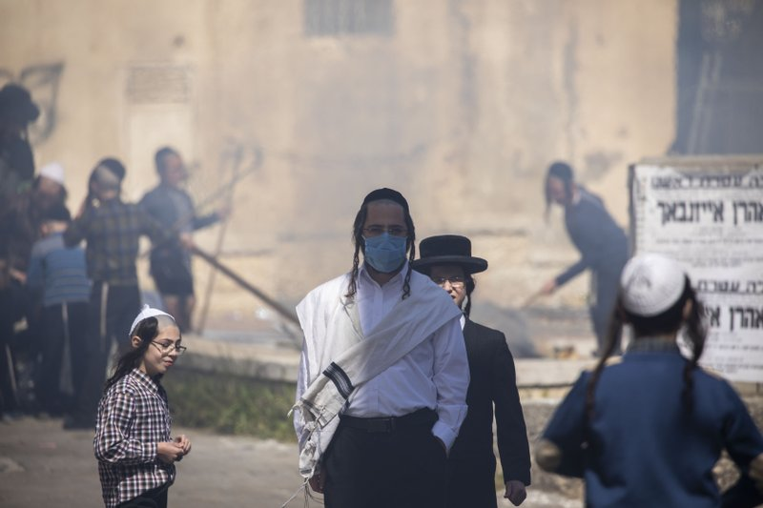
An ultra-Orthodox Jewish men wears a face mask as children burn leavened items in final preparation for the Passover holiday in the Orthodox neighborhood of Mea Shearim in Jerusalem, Wednesday, April 8, 2020. Jerusalem authorities have said they will gather the bread and burn it in a big bonfire in one location to avoid large gatherings. But, some in the Mea Shearim neighborhood shunned the orders. (AP Photo/Ariel Schalit)

JERUSALEM (AP) — Each year, Patricia Sheetrit and her family gather with in-laws for the first night of Passover, bringing together some 20 people for the holiday’s main event, the festive meal known as the Seder.
But like most Israelis, Sheetrit and her husband will be stuck at home this year — holding a bare-bones Seder for two.
“Everyone is sad and alone, and everyone is worried about one another,” Sheetrit said.
As a modern pandemic afflicts the globe, Israeli Jews are being forced to scale back or cancel beloved traditions and rituals marking Passover, the holiday celebrating Israelites’ freedom from Egyptian bondage and referencing biblical plagues.
Communal preparations have been canceled. Police are enforcing stay-at-home orders and a general lockdown through Friday morning. Families are turning to videoconferencing in hopes of capturing a small slice of the holiday spirit.

Lot of Families, Seniors and Singles
Having to Be at Seders Alone
“There’s a lot of families, a lot of seniors, a lot of singles who will be having Seder alone, and that’s very challenging because this is really the family holiday,” said Rabbi Kenneth Brander, president of Ohr Torah Stone, a network of 27 modern Orthodox institutions.
The week-long festival starts Wednesday night with the Seder, a large meal that retells the Exodus story. A highlight of the joyous dinner is the chanting of the 10 plagues — the biblical afflictions that pushed the Pharaoh to free the Israelite slaves.
Ordinarily, most Israeli Jews — religious and secular alike — spend the Seder with extended family in an experience akin to Thanksgiving. It also is customary to invite strangers such as lone travelers or students.
But this year, Prime Minister Benjamin Netanyahu has ordered a general lockdown on Wednesday night, telling Israeli Jews that “every family will sit down for Seder night on its own.” Police plan to set up checkpoints in neighborhoods and on major highways to enforce travel restrictions.
Israel has over 9,400 confirmed cases of COVID-19, the illness caused by the new coronavirus, and at least 71 deaths.

Pandemic is Also Disrupting Festivals
Of Christians and Muslims
Jews make up about 80% of Israel’s population. The pandemic is also disrupting other faiths’ celebrations this month, including the Christian holiday of Easter and the start of the Muslim holy month of Ramadan.
Despite growing anxiety over spiking unemployment, and political paralysis after three inconclusive elections in the past year, Israeli Jews are still trying to salvage some holiday spirit.
Jewish tradition prohibits the consumption of leavened goods and instead requires eating matzo, a crisp, unleavened flatbread. The week leading up to Passover is marked by frenetic cleaning and preparations.
In the run-up to the holiday, many religious neighborhoods around the country set up gigantic cauldrons of boiling water for dunking kitchenware to make them suitable for use on Passover. On the morning before the holiday commences, it’s traditional to burn leftover bread outdoors.
This year, the Health Ministry has banned both communal activities as a precaution, though a small group of people in one neighborhood was seen illicitly cleansing plates on Tuesday. On Wednesday, residents in an ultra-Orthodox neighborhood in Jerusalem defied the orders and burned their leavened bread in a dumpster.

Jerusalem City Holding a Massive
Bon Fire to Destroy Baked Products
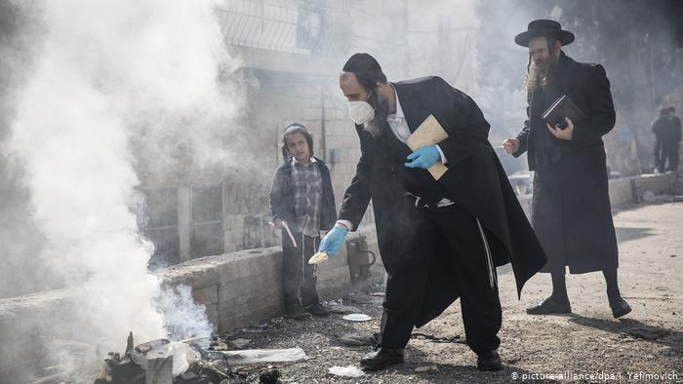
City Hall set up containers for residents to dump their remaining baked products. The containers were collected, and the city was holding a massive bonfire Wednesday to destroy them.
Synagogues also have been closed and holiday prayers are to be held individually at home due to a ban on public gatherings.“All the different things that happened both before and on Pesach, this year suddenly are not happening, or happening in very different ways than they always did,” said Rabbi Issamar Ginzberg, a Jerusalem-based ultra-Orthodox rabbi, referring to Passover by its Hebrew name.
Israel’s ultra-Orthodox population, which initially resisted safety precautions, has been hit especially hard by the outbreak, with an estimated 50% of the country’s cases. One ultra-Orthodox city, Bnei Brak, has been placed under a closure.
Ginzberg said he and most other ultra-Orthodox families are strictly observing social distancing rules. “This year everyone’s essentially staying home, nuclear family only, and no guests, which is also something unique,” he said.
The effect on Israel’s collective psyche after weeks of a climbing death toll and stringent social distancing will come to a fore at the time of the Seder, said Yoram Yovell, a Hebrew University psychiatrist.
Even in the most difficult times in Jewish history, Jews managed to celebrate with their extended families, Yovell said. The disruption of a key family event like Passover will be “very demoralizing and very anxiety provoking,” he said, adding that Muslim communities may experience a similar trauma when Ramadan arrives.

Attempts to Raise Spirits by Calling
On Residents to Sing from Balconies
To raise spirits, several Israeli towns are calling on residents to sing songs from the Hagaddah, the text read at the Seder, from apartment balconies. Yovell suggested leaving the front door open so that people “can hear their neighbors and the neighbors can hear them.”
“That is a way of — while still complying with the social distancing regulations — getting a sense of togetherness,” Yovell said.
For many, Zoom videoconferencing will be the centerpiece of their Seder table this year. A group of Sephardic, or Middle Eastern, rabbis even issued a ruling permitting the elderly, sick and quarantined to use video chat during the holiday meal, despite an Orthodox prohibition on using electronics on holidays.
Sheetrit, who has three grown children and a young granddaughter, said her extended family intends to hold a digital Seder over Zoom — “to feel somewhat together during this loneliness.”

Reprinted from the April 8, 2020 dispatch of the AP (Associated Press)

Rav Shimon Galai Cutting Wheat
For Matzos for Pesach 5780
Reprinted from the August 18, 2020 website of Matzav.com Photos from JDN.
Matza for Russia
Weekly Story by Rabbi Sholom DovBer Avtzon

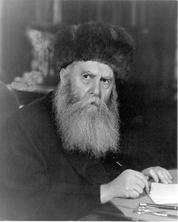
The Frierdiker Rebbe, zt”l

As noted, I have begun researching and writing about the life of the Frierdiker Rebbe (Rabbi Yosef Yitzchak Schneersohn, 1880-1950). This week I am posting a chapter in his life that is not well-known. (It is primarily based on his letters in vol. 16, of his Igros Kodesh). Obviously, I hope to find out more details of this endeavor and all of his communal work. As always, your feedback is always appreciated.
The following year, there was a scarcity of wheat in Russia, which meant that there wouldn’t be any flour to bake matzos. So on the 17th of Teves 5689 (1929), the Rebbe instructed his son in law, Rav Shmarayahu Gurary and the chossid (and Latvian parliamentary member) Reb Mordechai Dubin, to apply for a permit from the Russian embassy to send 28 train wagons of matza to the Jews of Russia.
When over a month passed and the embassy’s reply was that they are still waiting for the authorities to make a decision, the two of them went to Germany and applied at that embassy. Shortly afterwards, the Russian ambassador to Germany informed them that the government would allow the transport of 50 wagons, as long as all expenses of delivery are covered.
Being that the Rebbe was in Riga and the matzos were going to be sent from Riga, they showed this telegram to the Russian ambassador in Riga, but initially he replied, he was not given the official permission. But after persisting for a few days, they received permission to send the first five wagons, plus the fee of five aguros (coins) per kilogram of matza.

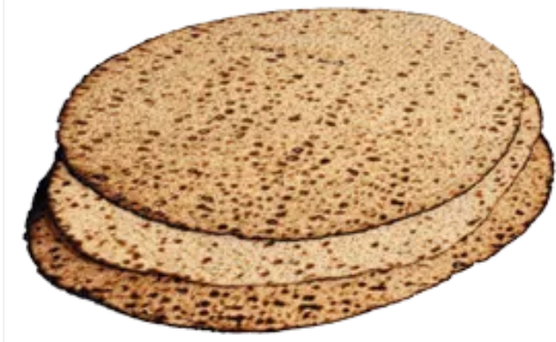
After these were sent, the embassy demanded the exorbitant price of two rubles for every additional kilogram. However, after negotiations, they agreed to the fee of a half ruble per kilogram and another 23 wagons of matza were sent to 17 major cities throughout Russia.
In addition to the matza they sent packages of kosher for pesach wheat to 5689 families/individual addresses in 404 towns and villages.
The Rebbe initially was hoping that the Joint would continue supporting his efforts on behalf Russian Jewry, however, in mid –Shevat it became apparent that they are not planning on doing so.
The Rebbe then discussed it with Reb Chaim Ozer of Vilna, who went to discuss it with the Chofetz Chaim. The Rebbe then sent letters to numerous rabbonim and organizations in Europe, Eretz Yisroel America and the Far East, requesting their financial help and participation in this endeavor, asking that each place create a committee that is dedicated to this project. He also sent his son in law and Rabbi Dubin to France and England to arouse the Jews there to participate, and when the Rashag returned, Rabbi Hidersheimer went with him to Belguim, to fundraise for this project.
On the eve of 13th of Nissan the Rebbe was informed that all the matzos and packages arrived at their destinations

Reprinted from the Parshas Mishpatim email of Rabbi Avtzon’s Weekly Story. Rabbi Avtzon is a veteran mechanech and the author of numerous books on the Lubavitcher Rebbeim and their chassidim. He can be contacted at avtzonbooks@gmail.com

They had participated in large amounts during the years of 5680-5687 (1920-1027).

